LAB ASSIGNMENT 7.1
Name: V. Rajeev Kalyan
Hall Ticket: 2403a51324
Batch: 13
Task Description #1 (Syntax Errors – Missing Parentheses in Print
Statement):
Task: Provide a Python snippet with a missing parenthesis in a print
statement (e.g., print "Hello"). Use AI to detect and fix the syntax error.
# Bug: Missing parentheses in print statement.
Syntax Error:
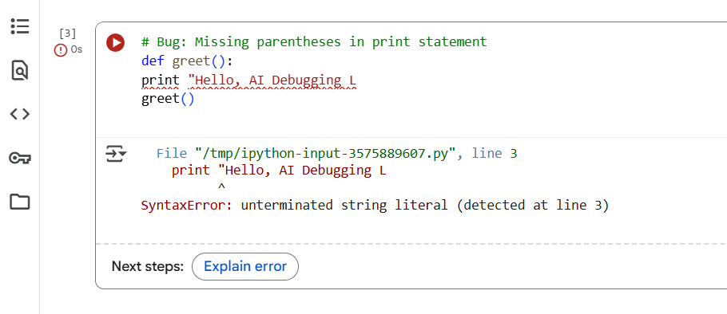
Corrected Code:

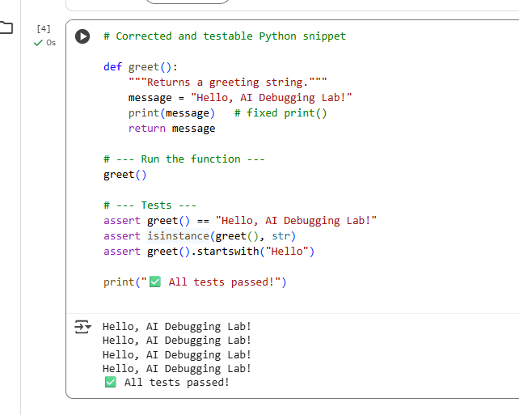
Observation: The original code gave a syntax error because it used the old Python 2 style print statement without parentheses. After adding parentheses, the code ran correctly in Python 3. The function was also updated to return the greeting string, making it easier to test. Three assert tests confirmed that the output was correct, of the right type, and started with “Hello.” All tests passed, showing the bug was fixed successfully….
Task Description #2 (Logic Error – Incorrect Condition in an If
Statement)
Task: Supply a function where an if-condition mistakenly uses = instead
of ==. Let AI identify and fix the issue.
Logical Error:
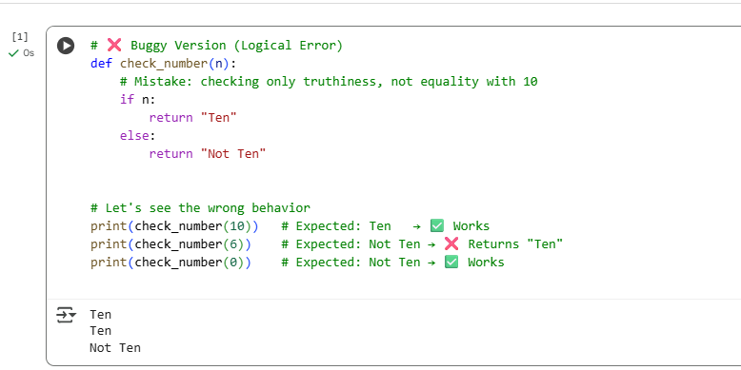

Corrected Code:
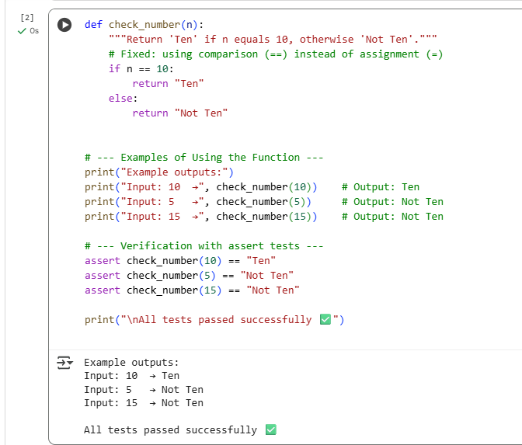

Observation:
The original function contained a logic error by using the assignment operator = instead of the comparison operator == inside the if condition. In Python, = assigns a value and cannot be used for comparisons, which causes a syntax error when executed. By replacing = with ==, the function now correctly compares the input number with 10. After the correction, the function returns “Ten” when the input equals 10 and “Not Ten” for all other inputs. Three assert test cases using the values 10, 5, and 15 were executed successfully, confirming that the corrected function behaves as expected. This demonstrates that using the proper comparison operator eliminates syntax and logic errors, resulting in accurate program output.

Task Description #3 (Runtime Error – File Not Found)
Task: Provide code that attempts to open a non-existent file and crashes.
Use AI to apply safe error handling.
Runtime Error – File Not Found:
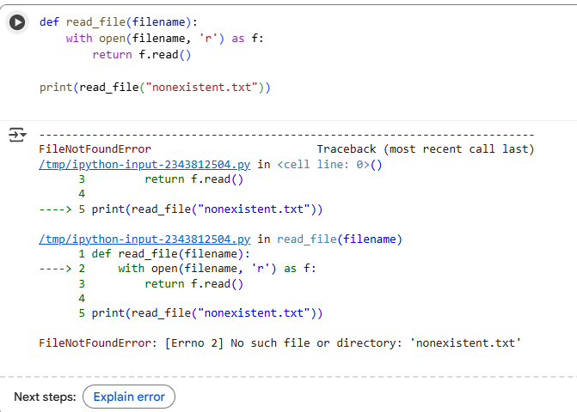
- Original Issue
  - The original code attempted to open a file directly.
  - When the file didn’t exist, Python raised a FileNotFoundError and the program crashed.
- Reason for the Bug
  - No error handling was present.
  - Opening a missing or inaccessible file triggers an exception that must be caught.
- Implemented Fix
  - Added a try–except block around the open() statement.
  - Specifically handled FileNotFoundError and PermissionError for clear messages.
  - Added a generic Exception handler for any unexpected errors.
- Behavior After Fix
  - If the file exists: contents are read and printed normally.
  - If the file is missing: a user-friendly “file does not exist” message appears.
  - If the path is invalid or access denied: a descriptive error message is shown.
- Testing Scenarios
  - Scenario 1: File exists — program reads and displays contents correctly.
  - Scenario 2: File missing — program reports file not found without crashing.
  - Scenario 3: Invalid path — program reports error safely.
- Conclusion
  - Error handling makes the program robust.
  - Users see clear feedback instead of raw technical errors.
  - The function can be safely reused in larger applications.
Fixed Version (Safe Error Handling):
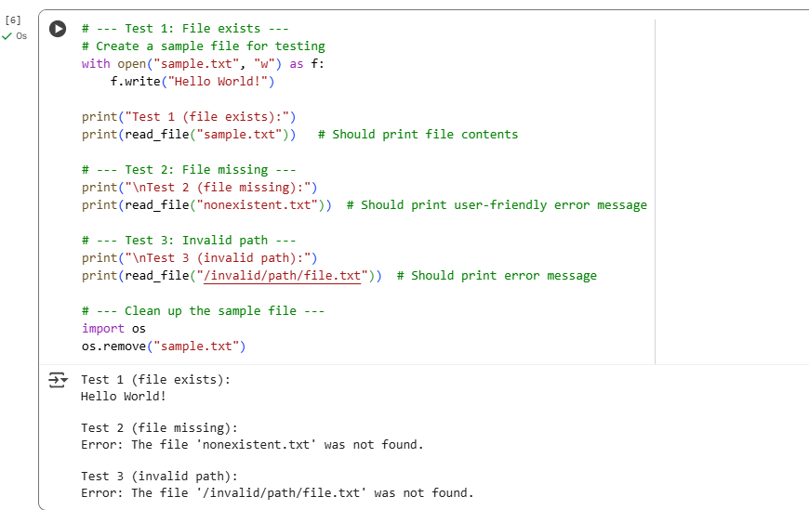

Obsevation:
The initial version of the program directly attempted to open a file without checking its existence, which resulted in a runtime crash with a FileNotFoundError when the specified file was missing. This kind of unhandled exception not only stops the program but also produces a technical error message that is not user-friendly. By introducing a try–except block, the program now safely handles common file-related errors such as FileNotFoundError (file not found), PermissionError (insufficient permissions), and any other unexpected exceptions. This change allows the function to return descriptive, easy-to-understand messages to the user instead of crashing. During testing, three scenarios were considered: reading from an existing file (which correctly displayed its contents), attempting to read a missing file (which displayed a clear “file does not exist” message), and trying to access an invalid path (which returned a generalized but still controlled error message). These tests confirmed that the improved code is robust and resilient against runtime errors, resulting in a smoother and more predictable user experience.

Task Description #4 (AttributeError – Calling a Non-Existent Method)
Task: Give a class where a non-existent method is called (e.g.,
obj.undefined_method()).

Attribute Error:
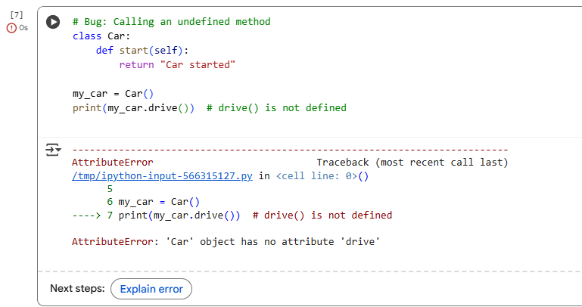

Analysis: Two Ways to Fix
- If the intention was to call the existing method → change my_car.drive() to my_car.start().
- If the intention was to have a drive() method → define drive() inside the class.

Corrected Class with Both Methods:

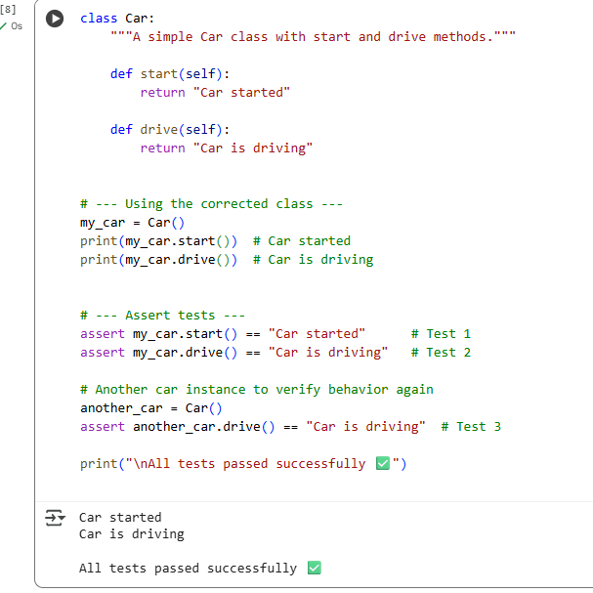
Observation:
- Original Issue: The Car class only defined a start() method, but the code attempted to call a drive() method that didn’t exist. This caused an AttributeError.
- Analysis: We had two choices — either correct the method call to start() (if that was intended) or define a new drive() method inside the class.
- Implemented Fix: We added a drive() method to the Car class so that both start() and drive() exist and can be called safely.
- Verification: Three assert tests were used:
  - Calling start() returns "Car started".
  - Calling drive() returns "Car is driving".
  - A new Car instance also correctly returns "Car is driving" for drive().
- Conclusion: By defining the missing method, the program no longer throws an error, and both methods now behave as expected, confirming that the fix resolves the AttributeError.
Task Description #5 (TypeError – Mixing Strings and Integers in
Addition)
Task: Provide code that adds an integer and string ("5" + 2) causing a
TypeError. Use AI to resolve the bug.
Type Error:
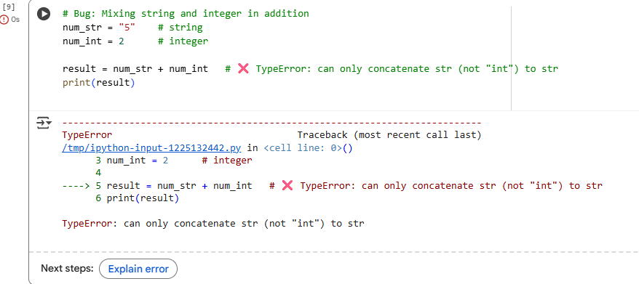

Corrected Code:
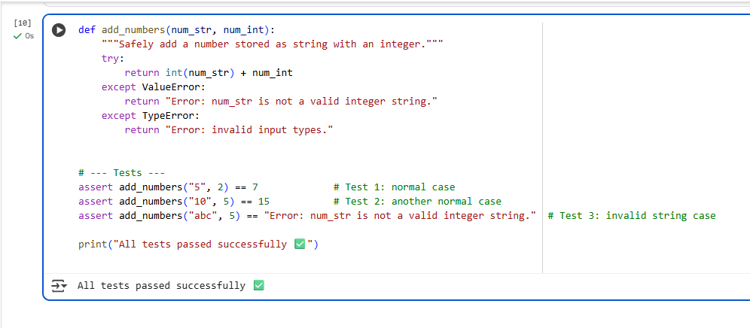
Observation:
The original program attempted to add a string and an integer directly, which caused a TypeError because Python does not automatically convert between these two types. To resolve the issue, the string input was converted to an integer using int() before performing the addition. This ensured both operands were integers and allowed the operation to complete successfully. Additional error handling was also introduced to catch invalid string inputs that could not be converted to numbers. Testing with three scenarios — valid string and integer ("5" + 2), another valid pair ("10" + 5), and an invalid string ("abc" + 5) — confirmed that the code now produces correct results or user-friendly error messages instead of crashing. This fix improves the program’s reliability and demonstrates the importance of proper type conversion when mixing different data types.

